***Useful links:***

FreeFEM website: <https://freefem.org/>

FreeFEM source code: <https://github.com/FreeFem/FreeFem-sources>

FreeFEM installation packages: <https://github.com/FreeFem/FreeFem-sources/releases>

FreeFEM YouTube channel: <https://www.youtube.com/channel/UCJlw6LHQt7UWXrH2uzGYZWw>

***Related Softwares:***

Gmsh: <http://gmsh.info/>

Mmg platform: <https://www.mmgtools.org/>

PETSc: <https://www.mcs.anl.gov/petsc/>

Paraview: <https://www.paraview.org/>

***Education Papers:***

Level-set method:

Allaire, G., & Pantz, O. (2006). Structural optimization with FreeFem++. Structural and Multidisciplinary Optimization, 32(3), 173-181.

<https://doi.org/10.1007/s00158-006-0017-y>

Phase field method:

Kim, C., Mingook, J., Takayuki, Y., Shinji, N., & Jeonghoon, Y. (2020). Freefem++ code for reaction-diffusion equation–based topology optimization: for high-resolution boundary representation using adaptive mesh refinement. Structural and Multidisciplinary Optimization, 62(1), 439-455.

<https://doi.org/10.1007/s00158-020-02498-3>

Density method:

Zhu, B., Zhang, X., Li, H., Liang, J., Wang, R., Li, H., & Nishiwaki, S. (2021). An 89-line code for geometrically nonlinear topology optimization written in FreeFEM. Structural and Multidisciplinary Optimization, 63(2), 1015-1027.

<https://doi.org/10.1007/s00158-020-02733-x>

***Topology Optimization using FreeFEM-PETSc-Mmg/Parmmg***

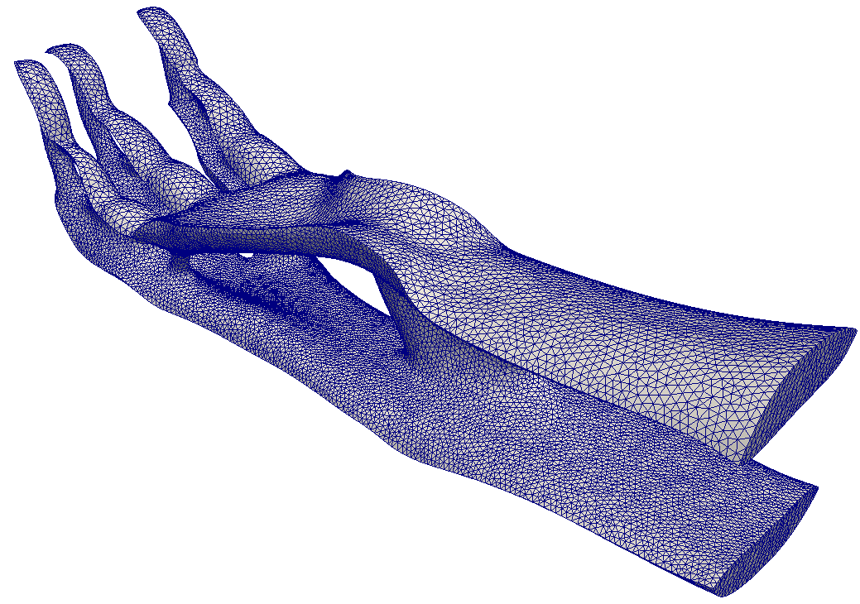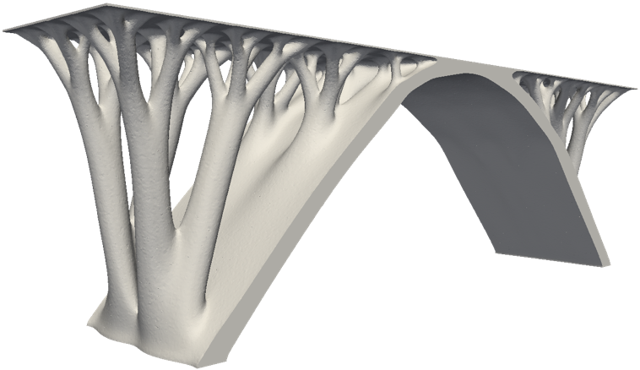

Hao Li, Takayuki Yamada, Pierre Jolivet, Kozo Furuta, Tsuguo Kondoh, Kazuhiro Izui, and Shinji Nishiwaki. "Full-scale 3D structural topology optimization using adaptive mesh refinement based on level-set method." Finite Elements in Analysis and Design 194 (2021): 103561.

<https://doi.org/10.1016/j.finel.2021.103561>

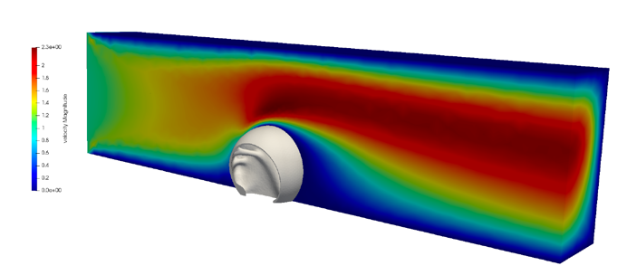 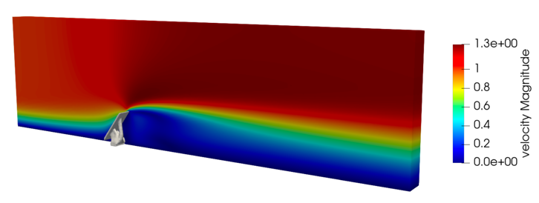

Hao Li, Tsuguo Kondoh, Pierre Jolivet, Kozo Furuta, Takayuki Yamada, Benliang Zhu, Kazuhiro Izui, and Shinji Nishiwaki."Three-dimensional topology optimization of fluid-structure system using body-fitted mesh adaption based on the level-set method." Applied Mathematical Modelling 101 (2022): 276-308.

<https://doi.org/10.1016/j.apm.2021.08.021>

<https://www.youtube.com/watch?v=6NIZ0QI4RmY&t=368s>

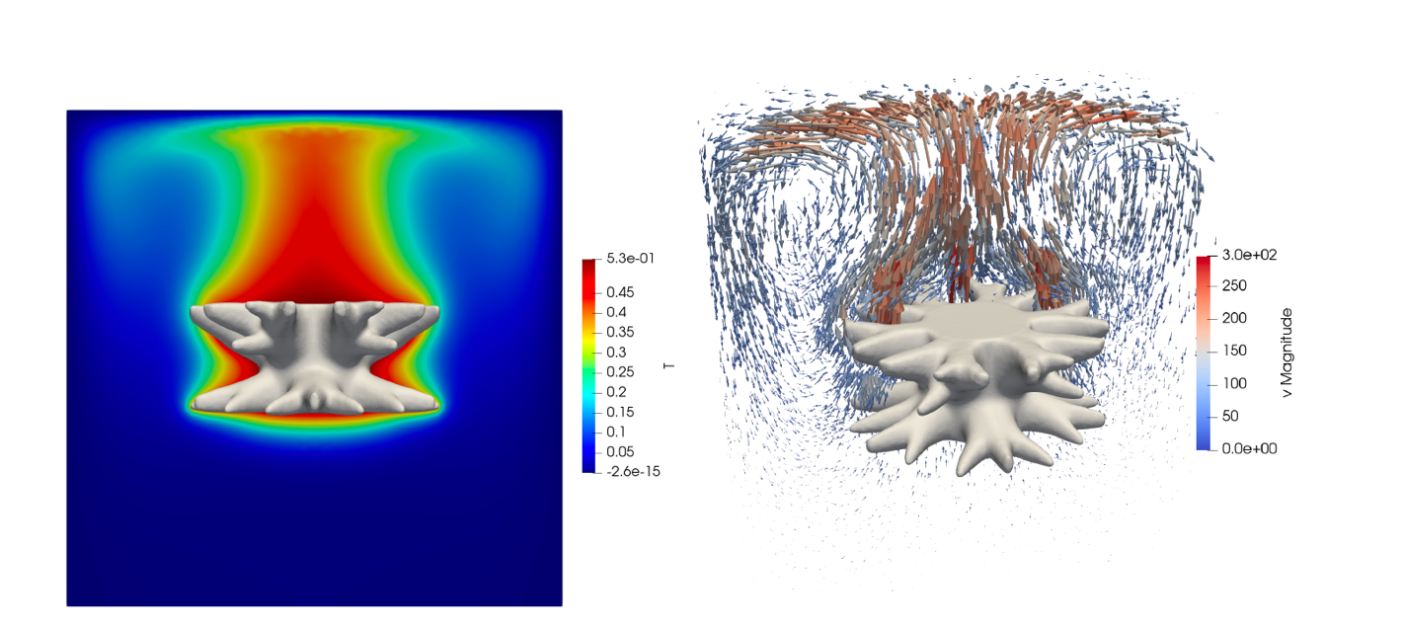

Hao Li, Tsuguo Kondoh, Pierre Jolivet, Kozo Furuta, Takayuki Yamada, Benliang Zhu, Heng Zhang, Kazuhiro Izui, and Shinji Nishiwaki."Optimum design and thermal modeling for 2D and 3D natural convection problems incorporating level set-based topology optimization with body-fitted mesh." International Journal for Numerical Methods in Engineering 123, no. 9 (2022): 1954-1990.

<https://doi.org/10.1002/nme.6923>

<https://www.youtube.com/watch?v=kJrw5l9U4DA&t=1145s>

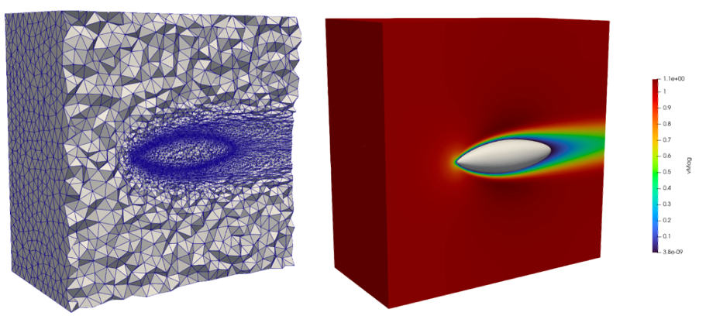

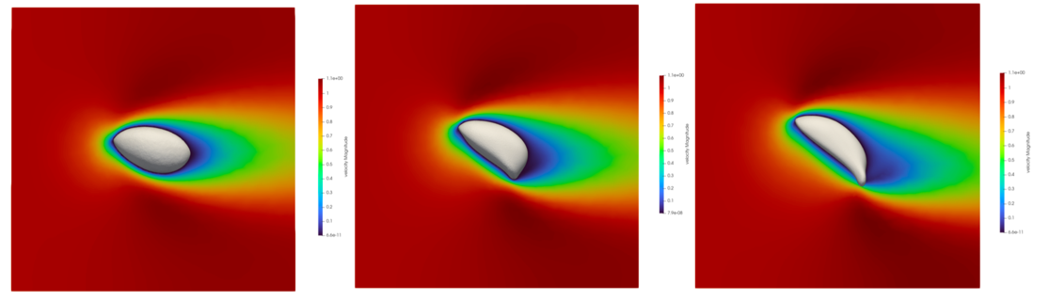

Hao Li, Tsuguo Kondoh, Pierre Jolivet, Nari Nakayama, Kozo Furuta, Heng Zhang, Bengliang Zhu, Kazuhiro Izui, and Shinji Nishiwaki."Topology optimization for lift-drag problems incorporated with distributed unstructured mesh adaptation." Structural and Multidisciplinary Optimization, DOI: 10.1007/s00158-022-03314-w, in press.

Preprint:<https://www.researchgate.net/publication/361498579_Topology_optimization_for_lift-drag_problems_incorporated_with_distributed_unstructured_mesh_adaptation>